**TECHNICAL REQUIREMENT DOCUMENT (TRD)**

**Project name**: WEBSITE (E-COMMERCE)

**Author**: Group 7

**Date accepted**: 02/04/2020

**Launch date**: 31/05/2020

**Project owner**: **AVISHKAR SHARMA**

## PURPOSE:

Main idea of our project is to create an e-commerce **Website** which will help the industries with the difficulties they are facing for supplying products in a better way.

**SOFTWARE:**

**Web2py** - Web2py is an easy-to-use framework & it encompasses utilities and no extra head for installation and configuration is required as it is portable and can be run on a USB drive too. It is based on the MVC pattern like many other python frameworks.

Web2py is composed of the following components:

* libraries: gluon package provides core functionality
* web server: The Rocket WSGI web server.
* The **admin** application: used to create, design, and manage other web2py applications. **admin** provides a complete web-based Integrated Development Environment (IDE) for building web2py applications. It also includes other functionality, such as web-based testing and a web-based shell.

Web2py tries to lower the barrier of entry to web development by focusing on three main goals −

* Python version - **3.7**
* Packages used is **Gluon** in Web2Py
* **Framework** : <http://www.web2py.com/init/default/download>

# HARDWARE:-

* Laptop – Core i7
* Mobile device (iOS, Android)
* Computers needed for the development: 2

# SCOPE OUT THE WORK:-

Manpower needed:-

* Number of people = 4
* Number of hours per person = 20.

**STEPS TO SETUP:-**

1). First step is to download web2py. We can use the given link (<http://www.web2py.com/init/default/download>).

Also make sure python 3.6/3.7 is installed.

2). Open the downloaded zip file and extract to see the contents where we can find the web2py application.

3). Our next step is to install the application using the windows installer or any installer.

4). Now, download the ecommerce website project zip file and extract it also.

5). Copy the extracted ecommerce folder to the applications folder in web2py application folder.

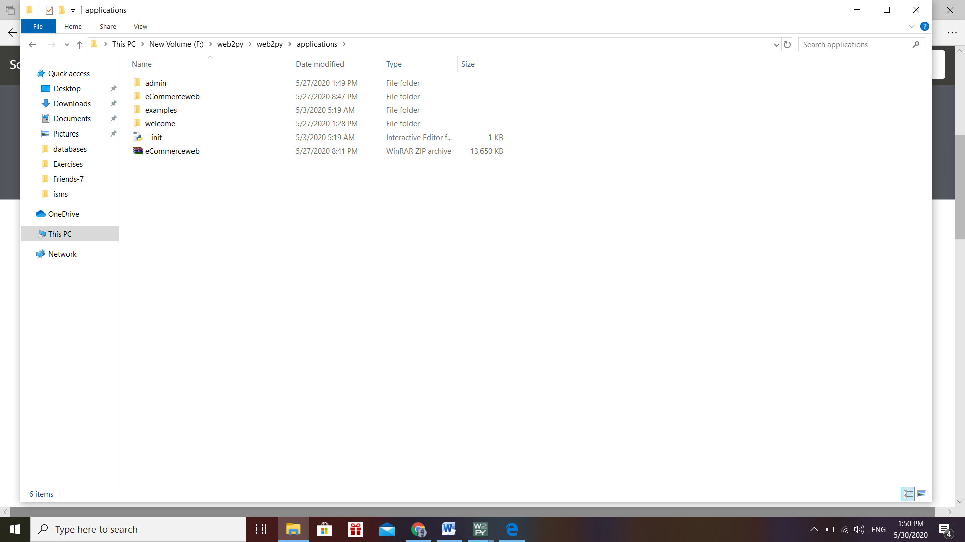

Figure 1

Open Web2py.py file in Pyzo Ide and then Run file as script

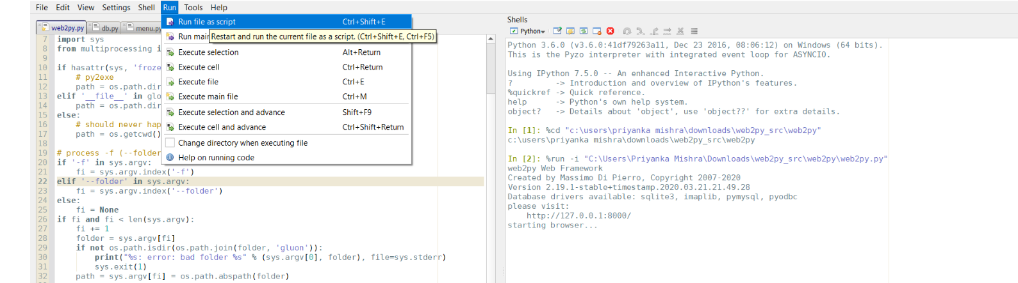

Figure 2

6) A window() will open which will ask to set the password. After setting the password, click on the start server button.

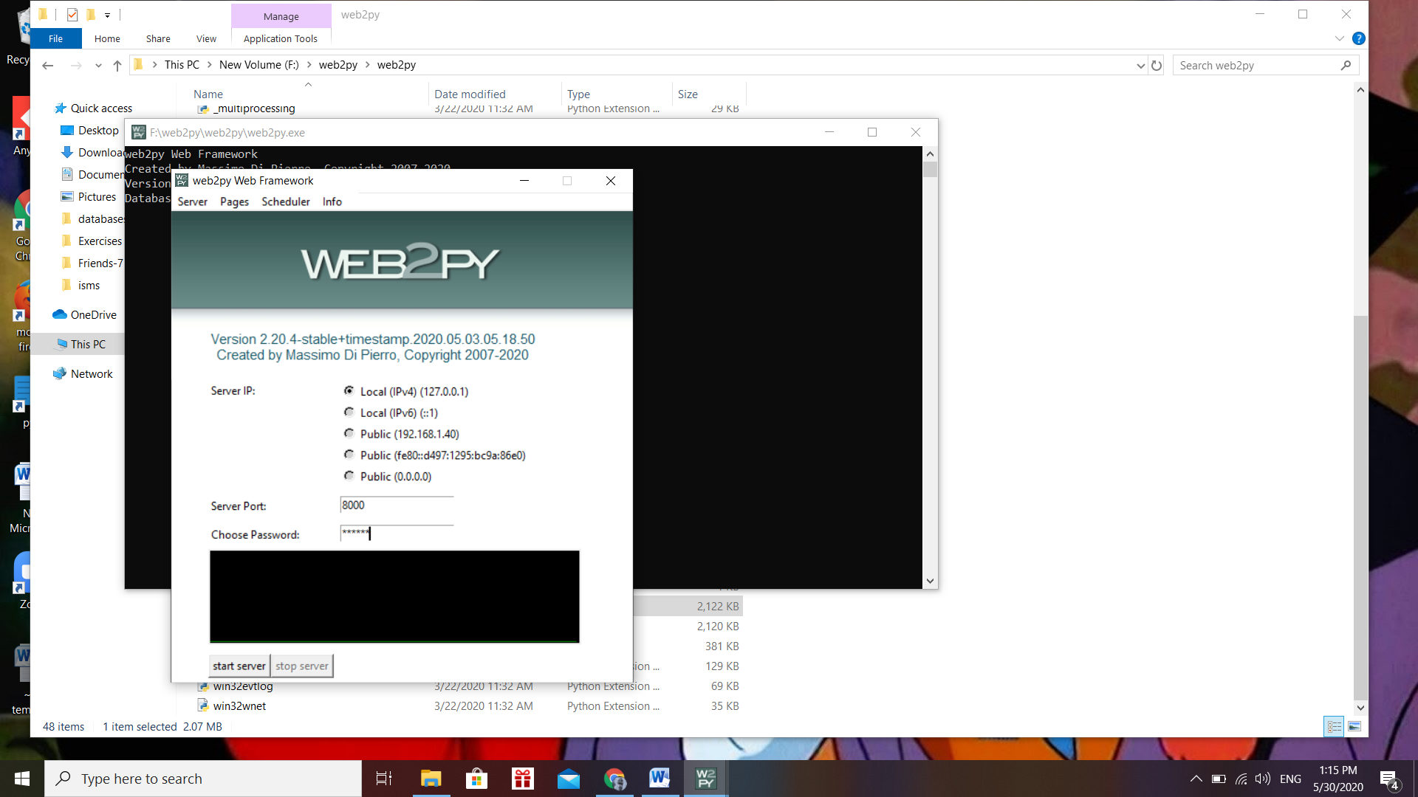

Figure 2

7). After starting the server, a new localhost window will open from where we have to select the “My Sites” tab from the top bar.

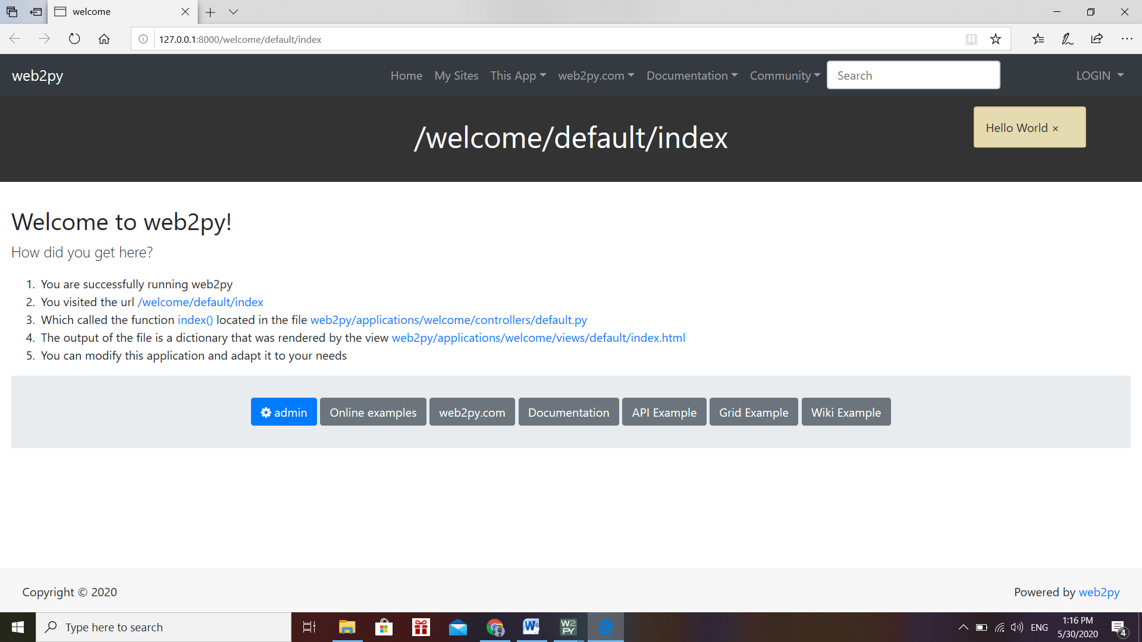

Figure 3

8). Previous step will take you to a new localhost window where you have to same password which you entered in step 6. Click login.

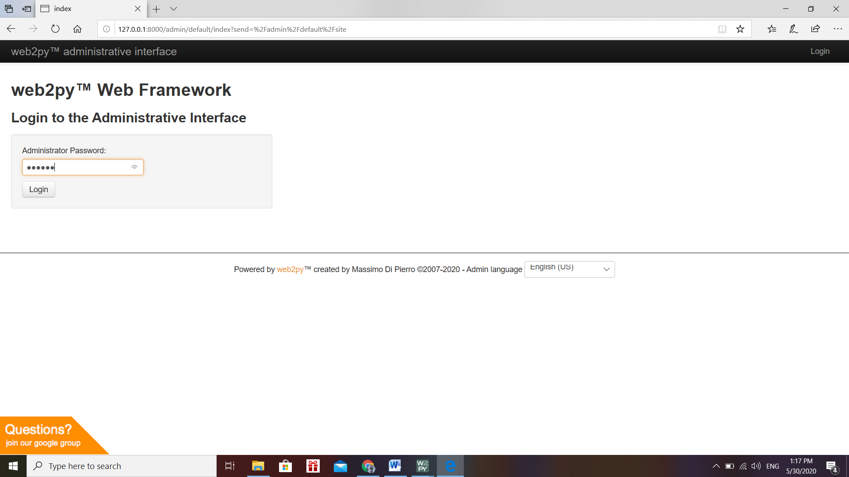

Figure 4

9). Open eCommerceweb folder .

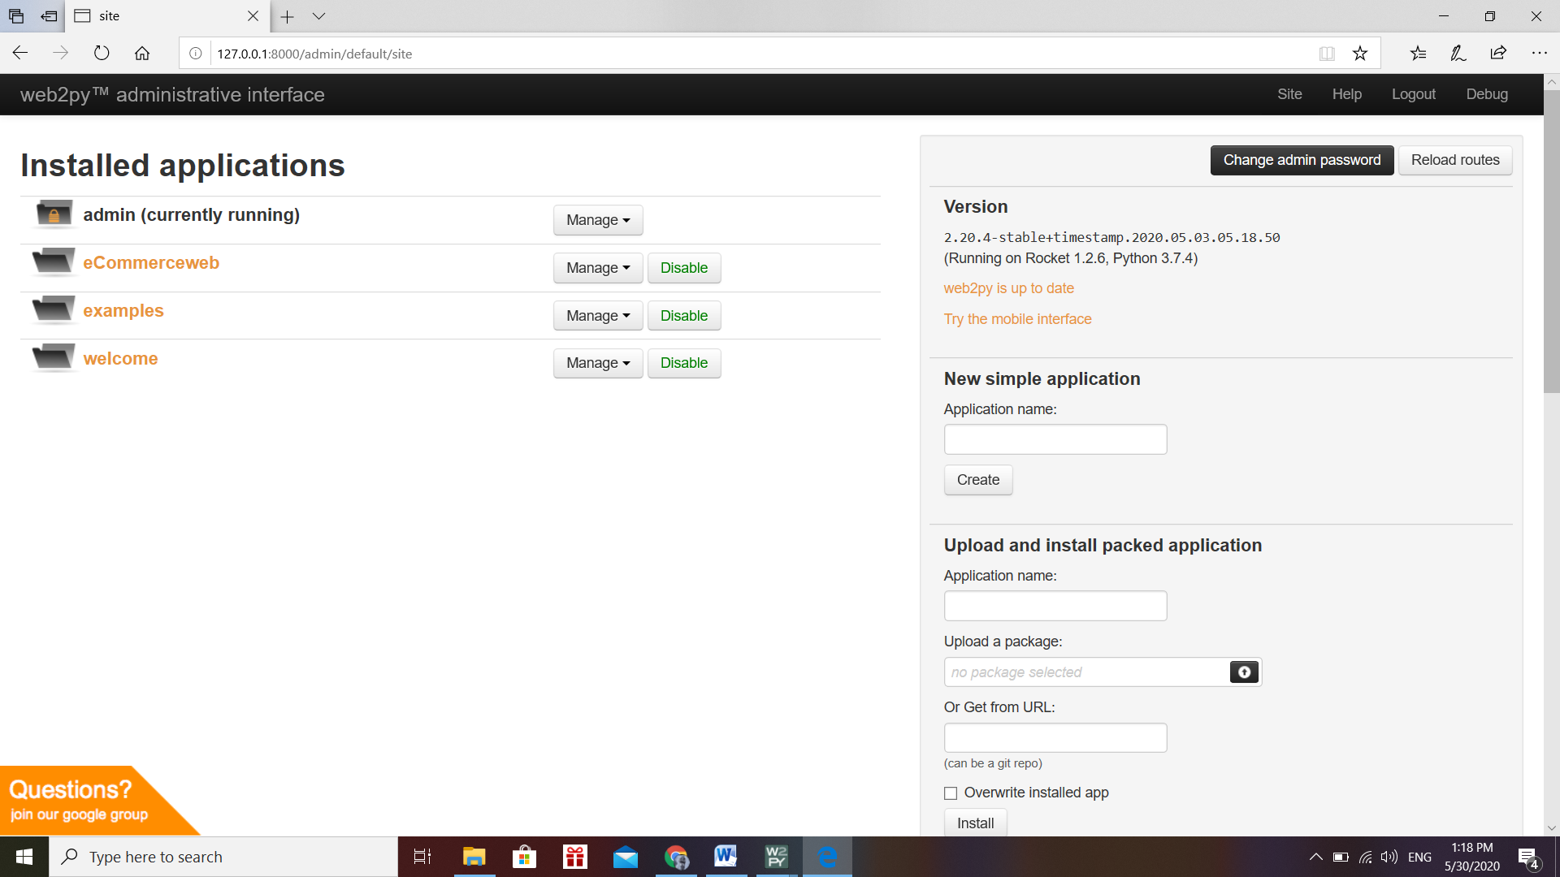

Figure 5

Click on eCommerceWeb Folder you will be redirected to the Dashboard.

10). And finally, you’ll reach the website.



Figure 6